**Market & Industry Analytics** **-Glassdoor Data**

**1. Project Overview and Objective**

Market & Industry Analytics using Glassdoor data involves cleaning, transforming, and analysing raw data using **Excel** and creating an interactive **Power BI dashboard** to derive meaningful business insights.

The main objective is to demonstrate data pre-processing techniques using Excel and an interactive Power BI dashboard visualization to make informed decisions.

**2. Data Sources**

* **Source Description and Timeline:** Bright Data /Google Search
* **Domain**: Market & Industry Analytics.

**3. Problem Statement**

* To analyse company ratings, compensation, benefits, and work-life balance to evaluate employer performance and employee satisfaction.
* To benchmark salaries, benefits, and employee reviews.
* To benchmark organizational performance and identify improvement areas in employer branding

**4. Attribute (Column /Features) Details:**

|  |  |  |
| --- | --- | --- |
| **Attribute Name** | **Data type** | **Description** |
| Comp_id | Integer / String | Unique Id to identify each Company |
| Company_Name | String (Text) | Company Name |
| Min_Employees | Whole Number | Minimum Employee Count |
| Max_Employees | Whole Number | Maximum Employee Count |
| Company_Size | String (Text) | Segment wise derivation |
| country_code | String (Text) | Foreign key to link region |
| company_type | String (Text) | Describes whether it is a private/public/Government/others |
| details_headquarters | String (Text) | Describes the Headquarters region |
| details_industry | String (Text) | Describes the company Industry |
| Industry_ID | Whole Number | Foreign Key to identify Industry group |

**5. Tools & Technologies**

* **Excel:** Data cleaning, transformation, and Pivot Tables.
* **Power BI:** Data modelling, DAX calculations, visualization, and interactive dashboard creation.

**6. Data Pre-Processing (Excel / Power Query)**

**Tasks Performed:**

* **Data Cleaning & Transformation:** Removed duplicate records, handled missing and invalid values (e.g., 99, blanks), standardized data formats, and created calculated columns for analysis readiness.
* **Filtering & Sorting:** Filtered irrelevant records and applied sorting to organize the dataset for focused and accurate analysis.
* **Data Summarization (Pivot Tables):** Used simple Pivot Tables for quick validation checks such as record counts, rating ranges, and to support fact table preparation.
* **Data Modeling (Fact & Dimension Tables):** Converted the raw dataset into Fact and Dimension tables where applicable to support a structured data model and efficient analysis in Power BI

**7. Data Modelling and DAX (Power BI)**

* **Data Model:** Established relationships between tables, defined cardinality, and created lookup tables where necessary.

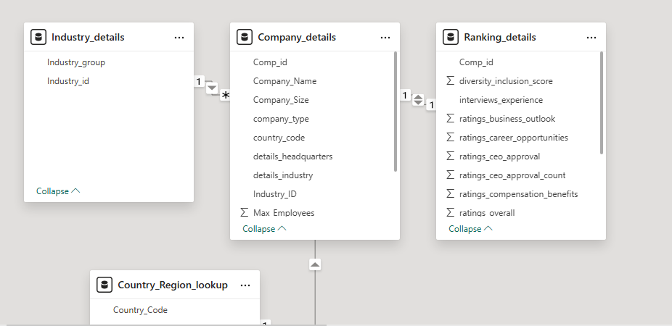

* **Calculated Columns & DAX Measures (Key Metrics):** Created calculated columns and DAX measures to derive key metrics used for data validation and building analytical visuals.

Total Companies =

COUNTROWS(Ranking_details)

Rated Companies =

COUNTROWS(

FILTER(

Ranking_details,

Ranking_details[ratings_overall] <> 99

)

)

Not Rated Companies =

COUNTROWS(

FILTER(

Ranking_details,

Ranking_details[ratings_overall] = 99

)

)

Avg Overall Rating =

AVERAGEX(

FILTER(

Ranking_details,

Ranking_details[ratings_overall] <> 99

),

Ranking_details[ratings_overall]

)

Avg Comp Benefits =

AVERAGEX(

FILTER(

Ranking_details,

Ranking_details[ratings_compensation] <> 99

),

Ranking_details[ratings_compensation]

)

Avg Career Opportunities =

AVERAGEX(

FILTER(

Ranking_details,

Ranking_details[ratings_career_opportunities] <> 99

),

Ranking_details[ratings_career_opportunities]

)

Recommend to Friend % =

AVERAGEX(

FILTER(

Ranking_details,

Ranking_details[ratings_recommend_to_friend] <> 99

),

Ranking_details[ratings_recommend_to_friend]

)

Avg Culture & Values =

AVERAGEX(

FILTER(

Ranking_details,

Ranking_details[ratings_culture] <> 99

),

Ranking_details[ratings_culture]

)

**8. Analysis and Visualizations (Power BI)**

**Dashboard Features:**

* Cards for key KPIs (Total Companies, Average Overall Rating, Recommend to Friend %)
* Bar & Column Charts for industry-wise and region-wise comparisons
* Clustered Charts to compare rating categories across industries
* Area Charts to show region-wise distribution of companies
* Scatter Charts to analyze relationships and identify outliers (e.g., Overall Rating vs Recommend %)
* Tables / Matrices to display detailed company- and industry-level breakdowns

* A screenshot of a computer

  AI-generated content may be incorrect.

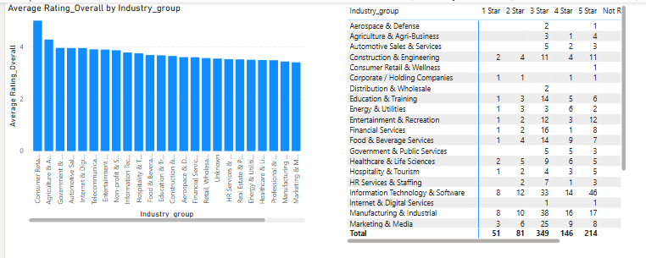

Dashboard-1-M&I provides a consolidated view of employee satisfaction and advocacy using Glassdoor data. It combines executive KPIs, industry and regional comparisons, and relationship analysis to identify trends and outliers in employer performance. The visuals support both high-level decision-making and deeper analytical exploration.

Dashboard-2-M&I combines a high-level performance indicator, relationship analysis between compensation and ratings, and a detailed industry-wise breakdown of company ratings to support both executive and analytical views.

**9. Insights & Conclusions**

**Key Findings**

* The **average overall company rating is ~4.0**, while the **recommend-to-friend rate is only ~42%**, indicating that positive ratings do not always translate into strong employee advocacy.
* A **positive but imperfect relationship** exists between overall ratings and employee recommendation, as shown in the scatter analysis.
* Several companies appear as **outliers**, particularly those with high overall ratings but comparatively low recommendation percentages.
* Industry-wise analysis shows **variation in rating distributions**, with some industries having a higher concentration of mid-to-high ratings, while others have a larger share of unrated companies.
* Regional distribution indicates that company representation is **uneven across regions**, which may influence aggregated trends.

**Analysis Insights**

**1️⃣ Descriptive Insights**

* Most companies cluster between 3.5 and 4.5 overall rating, suggesting generally positive employee satisfaction.
* Employee recommendation levels are more widely spread, with many companies falling below the 50% mark.
* Industries such as Information Technology and Manufacturing show higher representation and more rated companies compared to other sectors.
* A noticeable portion of companies remains unrated, which affects overall averages and insight depth.

**2️⃣ Diagnostic Insights**

* Higher compensation and benefits scores are associated with higher overall ratings, but do not consistently result in higher employee advocacy.
* The presence of high-rating, low-recommendation outliers suggests that **non-monetary factors** (e.g., **leadership quality, workload, career growth**) influence whether employees recommend their employer.
* Industries with a higher share of unrated companies may reflect **lower employee participation** rather than poor performance.

**3️⃣ Predictive Insights**

* Companies maintaining high overall ratings and strong recommendation percentages are more likely to sustain positive employer branding.
* Organizations with high ratings but low advocacy may experience **future engagement or retention challenges** if underlying issues are not addressed.
* Industries and regions with consistently lower recommendation levels **may face higher employee turnover risk** over time.

**4️⃣ Prescriptive Insights**

* Organizations should monitor **recommend-to-friend metrics alongside overall ratings** to gain a more complete view of employee sentiment.
* Organizations that offer a **healthy work-life balance and competitive monetary benefits** tend to achieve higher employee satisfaction and improved organizational performance.
* Employers with high satisfaction but low advocacy should conduct **deeper qualitative reviews** to identify disengagement drivers.
* Industry- and region-specific strategies should be considered to address localized employee experience gaps.
* Improving non-monetary factors such as **career growth, leadership transparency, and work-life balance** may help convert satisfaction into advocacy.

**10. Conclusions**

This analysis demonstrates that employee satisfaction and advocacy are influenced by a combination of monetary and non-monetary factors. While overall ratings provide a useful measure of employee experience, recommendation-to-friend metrics offer deeper insight into employee trust and loyalty. The Power BI dashboard enables stakeholders to explore these relationships interactively, identify outliers, and support data-driven decisions to improve employer branding and employee engagement.